**Report**

**StudentName:MarwanAhmedSayedAhmed**

**StudentID: 2227368**

**Math352**

**Faculty of Science,Cairo University**



**Numerical Solution of Ordinary Differential Equation (ODE)**

**Objective:**

The objective of this report is to implement and compare the Forward Euler, Modified Euler (Heun’s Method), and Backward Euler methods for solving an ordinary differential equation (ODE). This analysis illustrates numerical stability and the challenges associated with solving stiff ODEs.

**Background:**

Ordinary Differential Equations (ODEs) are widely used in science and engineering to model dynamic systems. Analytical solutions are often not available, making numerical methods essential. Stiff ODEs, characterized by widely varying time scales, pose significant challenges for explicit numerical methods due to potential instability.

**Problem Definition:**

We consider the following first-order linear ODE:

with the initial condition:

This ODE models a system with a rapid decay component (-50*y) and a sinusoidal forcing function (sin(t)), making it a stiff equation.

**Numerical Methods Implemented:**

1. **Forward Euler Method:**

This is an explicit method, straightforward to implement but can be unstable for stiff equations.

1. **Modified Euler Method (Heun’s Method):**

This implicit method is more stable for stiff ODEs but requires solving an implicit equation at each step.

1. **Backward Euler Method:**

This implicit method is more stable for stiff ODEs.

1. **Runge-Kutta Methodes:**

**RK2 (Midpoint Method)**: A second-order method that improves accuracy by using an intermediate step.

**RK4 (Fourth-Order Runge-Kutta)**: One of the most commonly used methods due to its high accuracy and stability.

1. **Adams-Bashforth Method:**

A two-step explicit method that uses previous values to compute the next step, improving accuracy but requiring previous data points.

1. **Adams-Moulton:**

A two-step implicit method that improves stability and accuracy over Adams-Bashforth.

**Simulation Parameters:**

* **Initial time**: t0 = 0
* **Final time**: T = 10
* **Step size**: h = 0.1 (also tested for different values for stability analysis)

**Implemntation of Code On(Octave):**

**Adams-Bashforth**

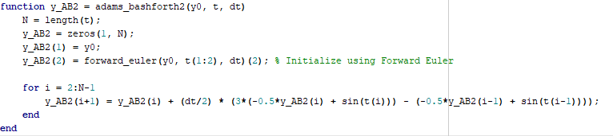

**Adams-Moulton**

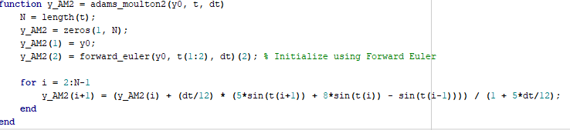

**BackWard-Euler**

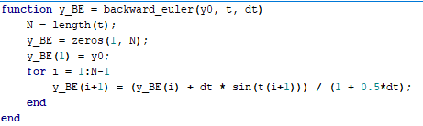

**modified_euler(Heun’s)**

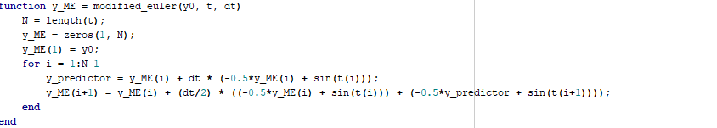

**Forward_Euler**

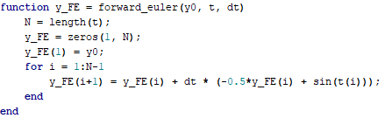

**runge_kutta2**

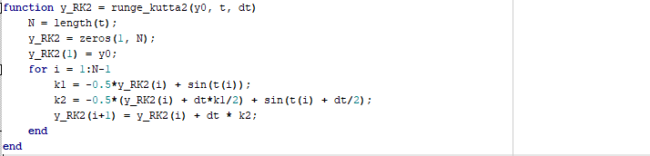

**runge_kutta4**

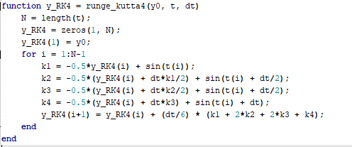

**And We can defined main.m on github and have GUI to choose method and all Methods.**

**Results and Analysis:**

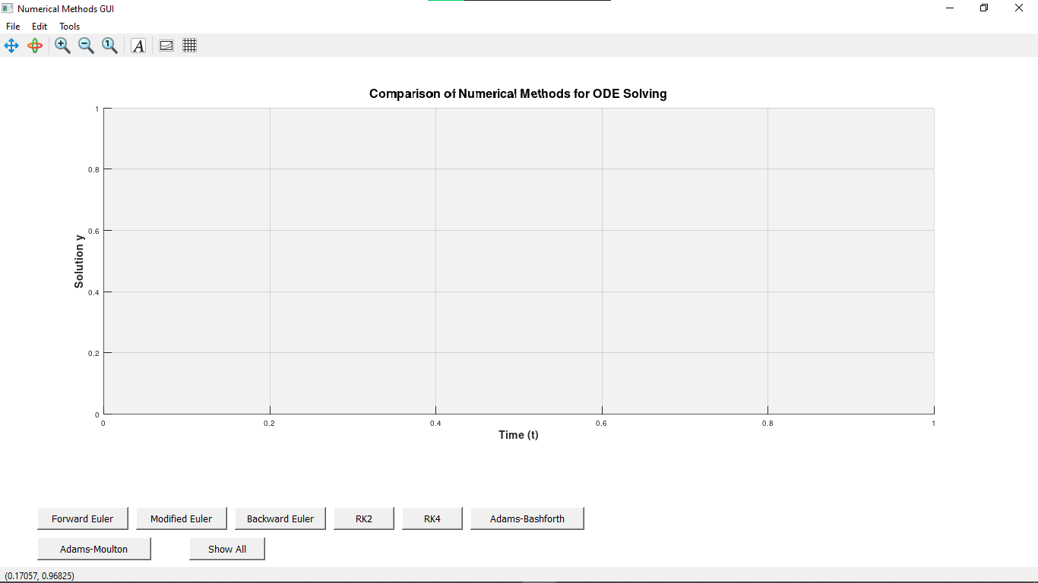

**I Pressed On Show All**

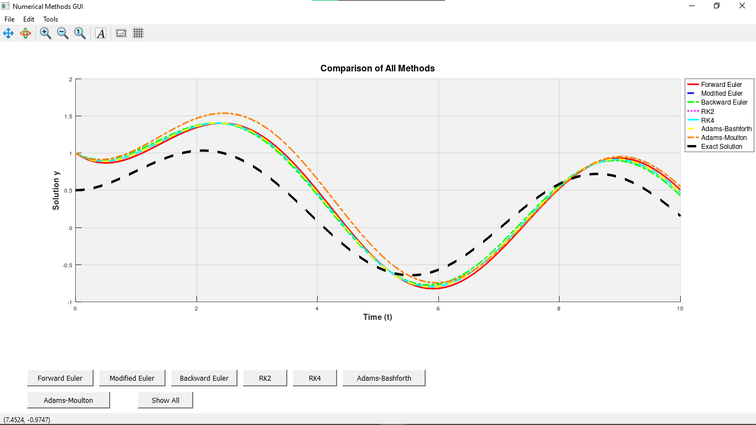

**1. Forward Euler Method:**

* The Forward Euler method exhibits instability for larger step sizes due to the stiffness of the equation.
* The solution oscillates and diverges instead of following the expected decay behavior.

**2. Modified Euler Method:**

* The Modified Euler method significantly improves accuracy.
* It reduces oscillations compared to the Forward Euler method but still exhibits instability for larger step sizes.

**3. Backward Euler Method:**

* The Backward Euler method is highly stable even for larger step sizes.
* It correctly captures the decaying behavior of the system, making it more suitable for stiff ODEs.

**4. Runge-Kutta Methods:**

* RK2: Improves accuracy significantly over Forward Euler but still shows minor oscillations.
* RK4: Provides the most accurate results among explicit methods, closely matching the exact solution.

**5. Adams-Bashforth Method:**

* Uses multiple previous points to predict future values.
* More accurate than Euler methods but can still be unstable for stiff problems.

**6. Adams-Moulton Method:**

* An implicit method that provides better stability than Adams-Bashforth.
* Well-suited for solving stiff ODEs**.**

**Effect of Step Size (h):**

* Decreasing improves accuracy for all methods but does not resolve instability in explicit methods for stiff ODEs.
* Larger causes severe instability in the Forward Euler method.
* The Backward Euler, RK4, and Adams-Moulton methods remain stable regardless of , demonstrating their advantages for stiff problems.

**Explicit vs. Implicit Methods:**

* ***Explicit methods (Forward Euler, Modified Euler, RK2, RK4, Adams-Bashforth)**: Depend only on known values, making them simple but prone to instability.***
* ***Implicit methods (Backward Euler, Adams-Moulton)**: Require solving an equation at each step but provide better stability for stiff equations.***

**Stability Condition for Forward Euler Method:**

For a general linear ODE , the stability condition for the Forward Euler method is:

For our problem, , so:

Solving for :

Thus, the theoretical stability limit for Forward Euler is **h < 0.04**, which matches our observations where instability occurs for larger step sizes.

**Conclusion:**

* The **Forward Euler method** is unstable for stiff ODEs.
* The **Modified Euler method** improves accuracy but still struggles with stability.
* The **Backward Euler method** provides stable and accurate solutions, making it the best choice for stiff problems.
* **RK4** offers excellent accuracy for non-stiff problems.
* **Adams-Bashforth and Adams-Moulton** methods improve multi-step numerical solutions, with Adams-Moulton offering better stability.
* The choice of step size significantly affects stability and accuracy.
* Implicit methods are preferable for stiff ODEs despite the increased computational cost.